SJSU Student Assistant System

Aviral Kumar
Sai Teja Desu
Varun Shah
Jay Desai

Abstract— There are around 32,000 students at San Jose State University and all of these students are enrolled in huge variety of courses which include technical as well as non-technical. Students attending the university come from different education background, culture, skills. Often when the students take up a course there are certain issues that face. On one hand we have these set of students who face these issues while on the other hand there are a set of students who have already faced these issues earlier and they can be of help to the current student in need of it. Currently there isn’t any platform that brings together these set of people together. SJSU Student Assistant System aims to solve the above problem. It brings together the set of students that need help and another set of students that can help. The student that provides some help can in turn require some help from other students in the community. Every student in the system will have his own profile, course, skills listed which the system can use to map to students that require help.

Introduction
The current problem of disconnection between 32000 students is what SJSU Student Assistant System is basically aimed to solve. The main idea behind this system is provide students a platform where they can come, raise the issues they have, meet students from their course work who in turn provide them with the solution or possibly some reference which can be useful for them. The goal of the system is to create a community of students where they can discuss and find solution to their issues and problems.
Student Assistant System has a simple and easy to use interface which allows the users to raise an issue, check who is ready to solve it. The system has some basic requirement which the user needs to fulfill before he can go ahead and use it. The student has to sign up with his details which include mandatory SJSU ID without which the user won’t be able to use the system as it is meant only for students of the university.
As soon as the student registers into the system he will have the options of editing his basic profile information. In the profile section he can specify the skill, course work he has already taken before. The user can save the information and then later on edit this if he wants to add some more information.
There is a section where the student can go and look up the currently open issues in areas which he has mentioned in his skill set. This page will list all the issues raised by different students. The student will have the options of viewing the issue and providing help to the student who has raised the issue.
The student who has logged in has also the option to raise issue in a particular area or subject on the “Raise Issue” page. The user can raise the issue and then wait for a user who is ready to provide help.

Student Sign Up Page
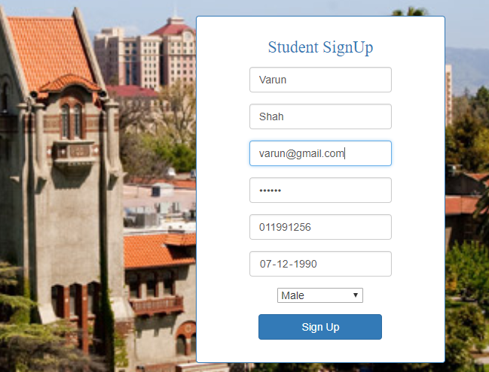
Figure 1.1 Student Sign Up

Shown above in the figure is the student sign up page. This is the first step towards using the system. The user has to enter below mandatory details before he can use the system :
- First Name
- Last Name
- Email Address
- Password.
- Student ID.
- Date Of Birth
- Gender.
Once the user enters the above details, he is successfully registered into the system. Using the credentials above the user can now log in to the system as shown in the next figure.

Student LOGIN PAGE

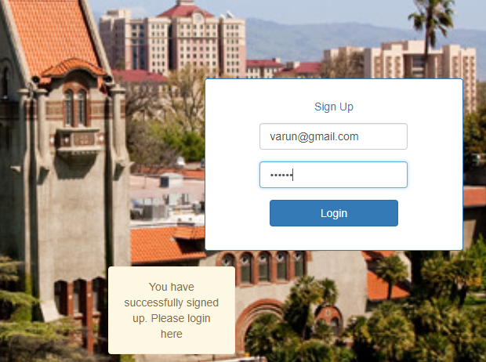
Figure 2.1 Student Log In

Above is the page which the student can use to log in to the system. After successfully registering the user needs to enter the email and password on this page to log in.

Student Profile Page

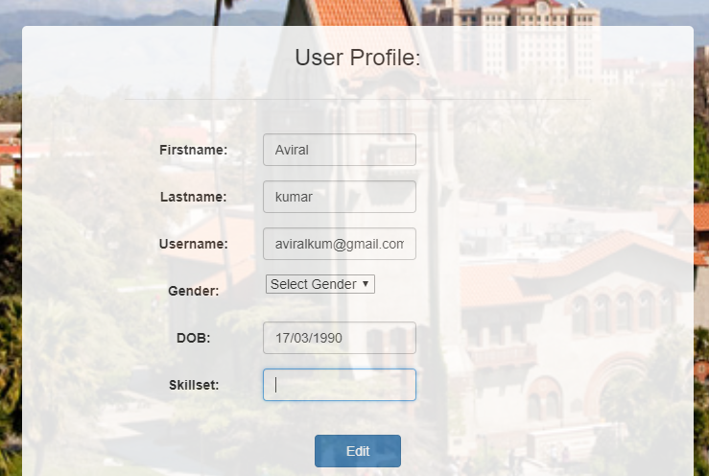
Figure 2.2 Student Profile

Above is the Student Profile page where the student has the option of editing his basic profile information like the skill set. He can update his or her skill set , courses taken up. The value in this field will be used to display the currently open issues in this skill set.

Open Issues page

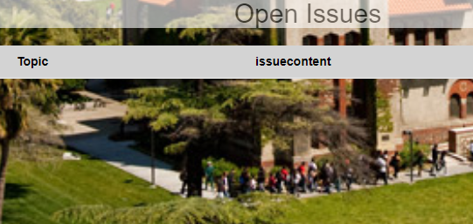
Figure 2.3 Open Issues Page

This is the place where the student can find all the currently open issues in the area which he has mentioned in his skill set on the user profile page. The topic name of the issue and the content of the issue along with it is displayed here. The user can scroll through the issues displayed and can provide help to the concerned user if he wants to the student who has raised the issue.

VI Recent Activity
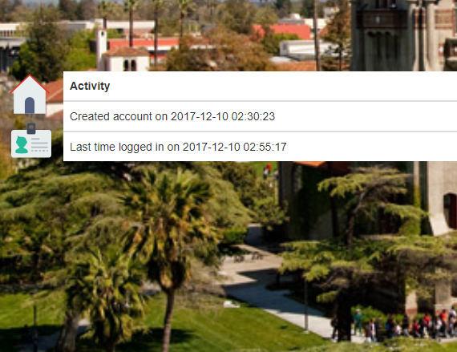
Figure 2.4 Recent Activity

Above figure shows the page where the student can see his recent activities. As shown in the figure above it displays two activities that were performed by the student:
- Account Creation
- Last login details.
It displays the date and time when the user created the SJSU Student Assistant System Account and also the date and time when the user last logged in to the system.

VI Raise issue
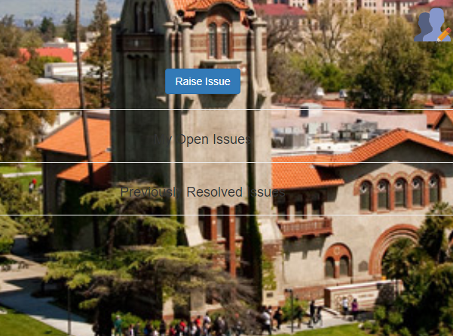
Figure 2.2 Student Profile
- Name Stand. Abbrev., in press.
- Y. Yorozu, M. Hirano, K. Oka, and Y. Tagawa, “Electron spectroscopy studies on magneto-optical media and plastic substrate interface,” IEEE Transl. J. Magn. Japan, vol. 2, pp. 740–741, August 1987 [Digests 9th Annual Conf. Magnetics Japan, p. 301, 1982].
- M. Young, The Technical Writer's Handbook. Mill Valley, CA: Univ

Figure 3.1 Raise Issue Page
The screenshot above displays the page where the student can
Raise his or her issues related to a particular subject or skill.
The user does this by clicking on the “Raise Issue”. Apart from
Raising the issue on this page the user also sees the list of open
Issues raised by him and also the list of issues resolved. This
Functionality helps the user in keeping track of the several issues
Raised by him and out of those how many are resolved and how
Many are still pending.

VII Front-End Technology

The Front-end of the “SJSU Student Assistant System” is designed
using React. The reason behind choosing “React” as the front end
was its component based approach towards the UI. It helped in
dividing the UI into a set of components which were easy to update.
Each component decides how it should be rendered. The components
designed can be re-used later. It also gives an enhanced user experience
which is very important.

VIII Back-End Technology

The Back-End of the “SJSU Student Assistant System” is built in
Node.js. Node.js is an open-source , cross-platform built on top of
The chrome’s JavaScript runtime for fast and scalable server-side
and networking applications. It enables event driven programming
To the web servers. Node.js works on the non-blocking IO model.
It also has wide variety of so called npm modules available on online
which can be easily integrated into the code and therefore is quite easy
to use.

XI Database Used

MongoDB which is a NoSQL database has been used to store all.
MongoDB is a open source , document oriented database. It uses JSON
Like documents to store data.The information of user and the issues
raised by a particular user are stored in the MongoDB.

